Effects of Sr(Co,Nb,Ta)O3 addition on the defect structures and electrical properties of ZnO-based varistors

Hsing-I Hsiang a, Huei-Ru Tsai a, Christian Pithan b, c

a Department of Resources Engineering, National Cheng Kung University

Tainan, Taiwan, 70101

b Institute for Electronic Materials, Peter Grünberg Institute (PGI-7), Forschungszentrum Jülich GmbH, 52428 Jülich, Germany

c Department of Materials Engineering, National Pingtung University of Science and Technology, Taiwan, 91201

Abstract

The present study reports about the effects of the addition of Sr(Co,Nb,Ta)O3 and transition metal cations (Co, Mn) on the microstructures, varistor properties, and point defect structures of ZnO varistors. Additions of Sr(Co,Nb,Ta)O3 and transition metal cations as donor dopants for the ZnO-matrix phase facilitate oxygen ionic conduction promoting the oxygen chemisorption at grain boundaries. The phase Sr(Co,Nb,Ta)O3 is locatedin the intergranular regions and promotes oxygen diffusion in the grain boundaries. The transition metal cations were oxidized and lost electrons during sintering, enhancing the chemical absorption of oxygen molecules at the grain boundaries and resulting in the formation of additional interface traps. ZnO varistors with a breakdown voltage as high as 4000V/mm and a large nonlinearity coefficient reaching a value of 65 were obtained by co-doping with the intergranular phase Sr(Co, Nb, Ta)O3 and transition metal ions of cobalt and manganese substituting zinc.

**Keywords**: ZnO varistors, SrCoO3, Sr(Co, Nb, Ta)O3, transition metal oxides, chemisorbed oxygen

1. Introduction

Compared with traditional arresters, ZnO varistors exhibit excellent electrical properties such as a large nonlinearity coefficient 𝛼, fast response time, large surge currents, and energy handling capability for absorbing transient overvoltage, as well as simpler fabrication processes. Therefore, ZnO has become the principle and most preferred material for manufacturing varistors quickly and is now widely used in technologies related to communications, electricity, transportation, industrial control, automotive electronics, and household appliances. 1,2 In recent years, the development of ZnO-based varistors withstanding large voltage gradients has been of urgent importance due to the need for materials with ultra-high breakdown voltages and the development of electronic circuits for integration and miniaturization. 3, 4 However, most of the ZnO varistors reported in the literature exhibit a too low voltage gradient (about 300 V/mm), which cannot meet the needs of miniaturization. 5

The composition series of current ZnO varistor ceramics are mainly based on the systems ZnO-Bi2O3, ZnO-Pr6O11, or ZnO-V2O5. However, these types of ZnO-based varistors have the following drawbacks: (1) Bi2O3 volatilizes seriously at high temperatures during sintering. During the cooling process, a eutectic liquid phase, being rich in Bi2O3 and with a relatively poor wettability on the major phase formed by the ZnO grains, mainly solidifies in the form of isolated inclusions at the triple junction, which leads to deterioration of regarding electric stability. 6 The varistor properties (𝛼, breakdown voltage, and leakage current) of ZnO-based varistors often degrade significantly after applying electric stress. It is reported that the application of electrostatic discharge (ESD) induces local heating due to large current densities concentrating in some portion of the varistor. Additives with low melting points such as Bi2O3 (820°C) easily evaporate after applying ESD stresses leading to the failure of varistors. Therefore, finding an effective varistor former with higher melting points is important. 7; (2) Although materials of the ZnO-Pr6O11 series exhibit excellent varistor performance, Pr6O11 is expensive, and the densification temperature is often higher than 1250oC, which is of disadvantage for industrial production, such as the need for the higher content of Pd in the inner electrode for multilayer chip varistors; 8 (3) V2O5 reveals a relatively high level of toxicity, and ZnO-V2O5 varistors exhibit lower breakdown voltages than ZnO-Bi2O3 varistors 9.

It has been reported that ZnO varistor ceramics containing additions of SrCoO3 exhibit excellent nonlinear current-voltage characteristics and a pronounced resistance against ESD 10. The densification temperature of ZnO-SrCoO3 is lower than the ones for materials based on the system ZnO-Pr6O11, reducing production costs. However, varistor properties of ZnO-SrCoO3 reported by Koga et al. 10-12 (coefficient of nonlinearity, 𝛼 =20-30 and breakdown voltage, Vb= 600V/mm) still can be improved. Moreover, the detailed effects of the additive SrCoO3 on the varistor properties and defect structures of ZnO ceramics have not been well understood.

The electrical varistor properties are dominated by an insulating, electrostatic barrier, i.e., a double Schottky barrier (DSB), formed along grain boundaries. It has been reported that the barrier height in ZnO-based varistors results from chemisorbed oxygen present at grain boundaries 13-15. In its gaseous state, Oxygen hardly penetrates into or migrates within a dense, polycrystalline ceramic body of ZnO 16, 17. A fast oxygen diffusion path along the intergranular regions must be provided in order to increase the content of adsorbed oxygen at the grain boundary. Stucki and Greuter 13 reported that Bi2O3, a good oxygen ion conductor at high temperatures, acts as a “grain boundary activator,” supplying excessive oxygen to ZnO grain boundaries. SrCoO3-𝛿 exhibits a cubic, oxygen-deficient perovskite structure with a high oxygen vacancy concentration, leading to a good ionic conductivity of oxygen.18 Co-doping of niobium and tantalum to SrCoO3 provides a synergistic effect of promoting the concentration of oxygen vacancies, ionic mobility, and surface electrons 19. Furthermore, transition metal oxides with several oxidation states can also promote oxygen concentration at ZnO grain boundaries 20.

Therefore, in this study, SrCoO3 co-doped with Nb and Ta was added to transition metal (Co and Mn) oxide-doped ZnO varistors to improve the varistor properties further. The effects of Sr(Co,Nb,Ta)O3-additions on the microstructures, defect structures and varistor properties were investigated using scanning electron microscopy (SEM), X-ray photoelectron spectroscopy (XPS), measurement of the current-voltage (I-V) characteristics, and impedance spectroscopy. The results obtained confirm that the addition of Sr(Co, Nb, Ta)O3 and transition metal cations into ZnO can significantly improve the varistor properties. The defect structures and chemical origins of the grain boundary potential barrier in Sr(Co, Nb, Ta)O3 doped ZnO varistors were proposed.

1. Experimental procedures

All ceramic compositions of the present study were prepared using solid-state reaction for the powder synthesis and densified by sintering in air. Reagent-grade SrCO3, Co3O4, Nb2O5 and Ta2O5 powders were used to synthesize SrCoO3 (SCO) and SrCo0.8Nb0.1Ta0.1O3 (SCNT). The powder mixtures were calcined in air at 1000℃ for 8 h. After calcination, the powders were ball-milled in ethanol for 8 h using Y-TZP balls. Mixtures of 97.96wt% ZnO, 1.72wt% Co3O4, and 0.32wt% Mn3O4 were calcined at 600oC for 2 h to obtain ZnO-Co3O4-Mn3O4 (ZCM) powders. ZnO-SCO, ZCM-SCO, and ZCM-SCNT powders were prepared as mixtures of reagent-grade ZnO or as synthesized ZCM with SCO or SCNT powders, respectively: 94wt% ZnO and 6wt% SCO, 94wt% ZCM and 6wt% SCO, and 94wt% ZCM and 6wt% SCNT. These powder mixtures were then milled for 18 h in ethanol with Y-TZP balls. The milled powders were dried in an oven, and PVA was added for granulation. After drying, the powders were uniaxially pressed at 100 MPa into disks with 8 mm diameter and 0.6 mm thickness, and the resulting green bodies were sintered at 1100℃ for 2 h in air and furnace-cooled to room temperature.

The relative densities of the as-sintered pellets were calculated from the ratios of apparent density and true density. The true density was measured with a helium pycnometer (Accupyc 1330, Micromeritics, Norcross, GA). The Archimedes method was used to measure the apparent densities of the sintered samples. The identification of crystalline phases was determined using X-ray diffractometry (Siemens D5000, Brucker, Karlsruhe, Germany, CuK𝛼1 radiation). Scanning electron microscopy (SEM, Hitachi SU-1510, Tokyo, Japan), and energy dispersive spectroscopy (EDS, Bruker, XFLASH-Detector 6/10, Germany) were used to observe the sintered pellets’ microstructure and to inspect their chemical compositions.

The current-voltage (I-V) characteristics were measured using a Keithley source meter, Model 2410. The coefficient of nonlinearity α was obtained from the equation: α = (logJ2 - logJ1)/(logE2 - logE1), where J1=0.1 mA/cm2，J2=1 mA/cm2, and where E1 andE2: represent the electric fields corresponding to the current densities J1 and J2, respectively. The breakdown voltage (Vb) was measured at a current of 1.0 mA, and the leakage current was measured at 0.8V1mA (80% of the breakdown voltage). The thickness of ZnO-SCO for I-V characteristics measurement was about 0.54 mm; however, due to the higher Vb, the thicknesses of ZCM-SCO and ZCM-SCNT for I-V characteristics measurement were ground to about 0.17-0.18 mm. The chemical compositions of the ceramic samples were also analyzed by X-ray photoelectron spectroscopy (XPS, ESCA PHI 5000 Versa Probe) in order to understand more precisely the valence states of different ionic species present. For the measurement of electric properties, electrodes were applied by printing silver paste on both sides of as polished sintered samples and by subsequent firing at 700 °C for 30 minutes. The impedances of the sintered bodies in the temperature range of 25-300°C were analyzed with an electrochemical analyzer (SI 1260, Solartron Analytical, UK). Equivalent circuit fitting of impedance spectra was performed using the software packages ZPlot and Zview (Scribner Associates Inc, North Carolina, USA). The resistance values obtained after fitting were used to calculate the activation energies of electric conduction for the bulk ZnO or ZCM-phase and for the grain boundary regions using the Arrhenius equation. 3. Results and discussion

The X-ray diffraction patterns of SCO and SCNT after calcination are shown in Fig.1. The compounds identified in SCO powders are mainly the hexagonal phase SrCoO2.52 and as secondary phase Sr6Co5O15. It is consistent with the observation that pure SrCoO3 can only be obtained at higher calcination temperatures and in a simultaneously oxygen-rich atmosphere 21-23. Wang et al. 21 reported that under ambient air atmosphere, this phase is easily thermally decomposed into Sr2Co2O5 at high temperatures and then absorbs oxygen during cooling to form Sr6Co5O15. It is difficult to synthesize a single perovskite structure, SrCo0.8Nb0.1Ta0.1O3. Li et al. 19 reported that a single perovskite structure, SrCo0.8Nb0.1Ta0.1O3, was obtained using a double sintering process in which samples were first sintered at 1200 °C for 10 h, then crushed and sintered at 1200 °C for another 10 h. In this study, SCNT was calcined at 1000 °C for 8 h to avoid severe aggregation. As a result, the SCNT powder consists of cubic SrCoO2.29 and secondary phase SrCo0.33(Nb,Ta)0.67O3 instead of a single perovskite structure. The main phase SrCoO2.29 in SCNT has a higher oxygen vacancy concentration than SrCoO2.52 in SCO 23, and therefore it can act as a rapid oxygen diffusion channel at the grain boundaries of ZnO-based varistor ceramics, hence enhancing oxygen diffusion along the grain boundary during cooling. More oxygen will be adsorbed at ZnO grain boundaries due to the enhancement of oxygen diffusion from the surface into the bulk, thereby improving the varistor properties.

Figure 2 and Table I show the I-V curves and varistor properties of the sintered varistors, respectively. The addition of the transition metal oxides Co3O4 and Mn3O4 can increase the coefficient of nonlinearity (α) from 14.82 to 53.02, and the breakdown voltage (Vb) from 611V/mm to 1741V/mm; When the varistor forming phase was changed from SCO to SCNT, the α value was further increased to 65.82; Vb was even increased to 4173 V/mm; in both materials systems, ZCM-SCO as well as ZCM-SCNT significantly reduced values of the leakage current were detected at the same time. Table II summarizes varistor properties reported in the literature for different materials systems and shows that the varistor properties obtained in this study are far better than those reported in the literature for other ceramic compositions. This comparison confirms that the addition of transition metal oxides and SCNT can greatly improve the varistor properties of ZnO varistors.

Figure 3 and Table III show the SEM microstructures, apparent densities, average grain sizes, and the number of grain boundaries per unit length of thickness of ZnO-SCO, ZCM-SCO, and ZCM-SCNT after sintering at 1100°C. No obvious secondary phases were observed for all samples based on SEM images; the trend of residual porosity after sintering in the samples is consistent with that of the measured values of apparent density; the decreasing sequence of grain size is ZnO-SCO>>ZCM-SCO>ZCM-SCNT. When the average grain size is larger and the sample thickness (D) remains unchanged, the number of grain boundaries is less (D = Grain size × Ngb). The breakdown voltage is proportional to the number of grain boundaries (Vb = Vgb × Ngb). Therefore, the breakdown voltage of ZCM-SCNT was larger due to the larger number of grain boundaries.

SEM images and EDS element mapping are shown in Fig.4. The element Co was homogeneously distributed in the grains. Since the ionic radii of Coion is close to that of Zn2+, an appropriate amount of tri- or divalent Co-cations substitutes Zn2+. The defect chemical reaction equations can be represented as below:

 (4)-(5)

In the case of ZnO-SCO, fewer Co ions are dissolved within ZnO grains compared to ZCM-SCNT due to the formation of excessive Co3O4 during cooling. For ZCM-SCO and ZCM-SCNT samples, the transition metal oxides, Co3O4 and Mn3O4, were first mixed with ZnO and calcined at 600°C. The valence states of these transition metal ions may change at different temperatures. The reduction/oxidation reaction equations of Co3O4 and Mn3O4 can be represented as below 28, 29:

 (6)-(8)

 (9)-(11)

After calcination at 600°C, Co and Mn mainly existed as trivalent cations (valence of +3) substituting divalent Zn2+ in ZnO varistors, resulting in a higher donor concentration.

Co and Mn ions were enriched significantly at some grain boundaries, as shown in Fig.4. The segregation of Co and Mn ions near the grain boundary areas during sintering may be due to large elastic strains induced when smaller Co3+ and Mn3+ cations are reduced into divalent but larger Co2+ and Mn2+. Such induced elastic straining may relax by segregation at the grain boundary region, as suggested by Bastami et al. 30.

Figs. 4 (g) to (i) show that Sr ions were mainly located at the grain boundaries. Almost no Sr could be detected in the interior of ZnO grains. Table IV shows the chemical compositions of four different areas (1-4) determined by EDS in Fig. 5. EDS analysis (Table IV), indicated that the Sr contents at the grain boundaries (areas 2 and 4 in Fig. 5) were much higher than that in the grain interior (area 1 in Fig. 5). The above results suggest that the precipitates at the grain boundaries were mainly composed of SrCoO3-𝛿, which is consistent with the observation of Koga et al. 11.

Figures 6 (a) and (b) represent thermogravimetric loss curves of ZnO-SCO, ZCM-SCO, and ZCM-SCNT during heating (heating rate 5°C/min) and cooling (cooling rate 2°C/min), respectively. The total weight changes recorded for ZnO-SCO, ZCM-SCO, and ZCM-SCNT after heating and cooling, respectively, are summarized in Table V. During heating, ZCM-SCO exhibited an obvious weight loss (0.84wt%). It is due to the reduction of the transition metal oxides, Co3O4 and Mn3O4, at high temperatures, into CoO and MnO and accompanied by oxygen loss. On the other hand, ZCM-SCNT exhibited a slight increase in weight (0.02wt%). This effect is probably caused by the varistor former, SCNT, with its larger concentration of oxygen vacancies, offering a relatively large capacity to absorb – not only – released oxygen gas evolving from the reduction of trivalent Co3+ and Mn3+ into Co2+ and Mn2+.

Both ceramic materials, ZCM-SCO and ZCM-SCNT, exhibited a significant increase in weight of 0.66wt% and 0.48wt%, respectively, upon cooling. The grain boundary phases SCO and SCNT exhibit a cubic, oxygen-deficient perovskite structure with a high concentration of oxygen vacancies, which acts as a fast oxygen diffusion channel in the intergranular regions between the ZnO grains. Therefore, SCO and SCNT located at grain boundaries can enhance the oxygen diffusion and the interaction of oxygen ions with the 3d energy level of the segregated transition metal ions incorporated there, close to the intergranular regions of the ZnO-phase, during cooling 31, resulting in a gain in weight.

Figures 7 (a)(d)(e) display the full XPS spectra of the ceramic compositions ZnO-SCO, ZCM-SCO, and ZCM-SCNT, illustrating the presence of the elements C, Sr, Co, O, and Zn. The XPS response of Co (2p) orbitals for ZnO-SCO, ZCM-SCO, and ZCM-SCNT are shown in Fig. 7 (b)(e)(h). Two main peaks at 780.0eV and 796.0eV can be attributed to Co2p3/2 and Co2p1/2, respectively. The peaks at 779.4 and 794.8eV correspond to Co3+. Moreover, the peaks at 781.1 and 796.5eV are attributed to Co2+, and the signal at 786.5 and 803.7eV were the satellite peaks of Co2+. 32-34 ZCM-SCO and ZCM-SCNT varistors exhibited a higher Co3+ content compared to ZnO-SCO (Table VI). ZCM-SCNT showed the highest content of Co3+ because the addition of SCNT enhances the diffusion of oxygen along the intergranular pathways and promotes the oxidation reaction of cobalt at the grain boundaries. Figure 7(c)(f)(i) illustrate XPS spectra of O (1s). The peaks at 530.2, 531.8, and 532.6 eV correspond to lattice oxygen, oxygen vacancies, and adsorbed oxygen, respectively 35, 36. The sequence of decreasing amounts of adsorbed oxygen in the varistors follows the descending order ZCM-SCNT>ZCM-SCO>>ZnO-SCO (Table VI).

The addition of SCNT revealing an excellent ion conductivity for oxygen promotes oxygen diffusion along the grain boundaries. Oxygen molecules at grain boundaries may take up electrons released from the transition metal cations upon reduction into the trivalent state, resulting in chemically adsorbed oxygen at the grain boundaries, which in turn forms more interface traps.

The sequence of decreasing concentration of oxygen vacancies in the varistors follows in descending order ZnO-SCO>ZCM-SCO>> ZCM-SCNT. The varistor former, SCNT, contains more oxygen vacancies compared to the phase SCO, but the amount of oxygen vacancies in ZCM-SCNT measured using XPS represents the lowest value observed. This reduction is probably due to oxygen vacancies carrying positive charges being annihilated by negatively charged adsorbed oxygen ions 37. Pithan et al. 38 investigated the defect chemistry of BaTiO3 thermistors with excessive BaO enriched in intergranular regions and observed that oxygen vacancies could be annihilated by a reoxidation reaction, leading to a decrease in the oxygen vacancy concentration. For ZCM- SCNT, the oxygen vacancies are easily combined with adsorbed oxygen to form lattice oxygen, reducing the oxygen vacancy concentration. The corresponding defect chemical reaction equation can be expressed as:

 (12)

(13)

The energy barrier is mainly affected by the amount of adsorbed oxygen at the grain boundary. 13-15 Adsorbed oxygen can effectively act as an electron trap, thereby enhancing the energy barrier height and improving the varistor properties. Based on the thermogravimetric losses and results obtained by XPS, the amount of the contents of adsorbed oxygen in the varistors decrease in the descending order ZCM-SCNT>ZCM-SCO>>ZnO-SCO. Therefore, the energy barrier and α value of ZCM-SCO and ZCM-SCNT are higher than those for ZnO-SCO.

Cole-Cole representations of the complex impedance, Z*, experimentally recorded at 250-300oC for ZCM-SCO and ZCM-SCNT varistor samples are shown in Fig. 8. The results show that the total impedance of the samples decreased with increasing temperature. The Z* plots suggest that the electrical response can be approximately modeled by an equivalent circuit of serially connected elements consisting themselves of one resistive and one capacitive element in parallel: R1||CPE1 and R2||CPE2 39. The constant phase element (CPE) is associated with a depressed semicircle in the corresponding Z* plot and is a calculated parameter as the circuit element behaves in between an ideal capacitor and resistor. The constant phase element (CPE) is comprised of two components; CPE-T and CPE-P. CPE-T is a pseudo-capacitance which is called Q, and CPE-P is related to the depressed semicircle in the Z* plot. The small semicircles definition is assigned to very similar values of most relaxation frequency, in relation to each relaxation phenomenon detected, one to bulk and the other to the grain boundary. Therefore, overlapping increases with the decrease in the magnitude of the difference between the most relaxation frequencies. The impedance data are fitted using the Zview software, and the best fit is determined and represented as a solid line in Fig. 8, respectively. The high-frequency nonzero intercept can be attributed to a semiconducting bulk component (R2). The large semicircles at intermediate frequencies can be ascribed to the resistive grain boundaries (R1). 40 The fitted parameters for the equivalent circuit are summarized in Table VII. The Arrhenius equation can be used to calculate the activation energies of electric conduction. The plot of vs. 1/T for the evaluation of conduction activation energy and the conduction activation energies of the grains and grain boundaries are shown in Fig. 9 and Table VIII. Fittings of the impedance data presented in the diagram of Fig. 8 show that the total impedance of ZCM-SCNT was larger than that of ZCM-SCO, and the total impedances for ZCM-SCNT and ZCM-SCO at 270°C were1.12x107 Ω and 2.52x106 Ω (extrapolated intersections at the low frequencies branch with the axis for the real part of impedance), respectively. Lee 41 reported that the total impedance was affected by the number of grain boundaries. The total impedance of the varistor decreases with decreasing the number of insulating grain boundaries. Therefore, the total impedance of ZCM-SCO per unit volume was lower than that of ZCM-SCNT due to the smaller number of grain boundaries.

Previous studies report that a defect energy level occurs at approximately 0.30eV below the conduction band for Co-doped ZnO 42-44; the defect energy level of zinc interstitials in ZnO is situated at about 0.5eV below the conduction band. The conduction activation energies of bulk conductivity for ZCM-SCNT and ZCM-SCO are 0.27 and 0.40 eV, respectively. Therefore, it is suggested that the activation energies of grain conduction for ZCM-SCNT and ZCM-SCO are affected by the cationic substitutions, CoZn**・** or MnZn**・**, and zinc interstitials, Zni**・**or Zni**・**. The conduction activation energies of the grain boundary for ZCM-SCNT and ZCM-SCO are 1.47 and 1.53 eV, respectively. Based on our XPS results, it can be concluded that the grain boundary conduction activation energy may be dominated by the oxygen adsorption near the grain boundary.

Figure 10 represents and illustrates schematically the different defect chemical mechanisms involved in ZCM-SCNT and ZCM-SCO varistor ceramics, which can be summarized by the following description: (a) The transition metal oxides, Co3O4 and Mn3O4, are added into ZnO and the powder mixtures are calcined at 600° C in air, resulting in ZCM. During incorporation into the host lattice of ZnO trivalent Co3+ and Mn3+ replace divalent Zn2+ generating extrinsic donors with the concentrations, and . Electric compensation of these donor centers occurs by the formation of zinc vacancies. (b) SCO and SCNT are added to ZCM and sintered at 1100 °C for 2 h. During the sintering process, oxygen loss occurred, accompanied by the formation of oxygen vacancies due to the reduction of transition metal elements and due to the release of lattice oxygen at high temperatures to the surrounding atmosphere. Co and Mn cations segregate near the grain boundaries during sintering: In this way, comparatively larger elastic strains associated with mismatching of ionic radii – when the divalent and relatively large cations Co2+ and Mn2+ are incorporated – may relax because the reduced, trivalent cations Co3+ and Mn3+ are smaller in size. (c) During the cooling process, oxygen ions preferentially diffuse along the grain boundaries, leading to the oxidation of transition metal ions segregated at the grain boundaries. The phases SCO and SCNT located at the grain boundary act as a fast oxygen diffusion channel to promote the migration of oxygen to the surface of ZnO grains and interact with the 3d energy level of the transition metal ions to form interfacial adsorbed oxygen at the grain boundary.

(d) During the cooling process, the reoxidation of the oxygen vacancies occurs, accompanied by the formation of electron holes. Moreover, the oxygen vacancies created during sintering can also be partially filled by oxygen ions to become lattice oxygen.

4. Conclusions

Synergistic co-doping with transition metal cations of Co and Mn, along with the addition of the phase SCNT, Sr(Co,Nb,Ta)O3, being enriched in intergranular regions, significantly improves the varistor properties of ZnO. The varistor former, SCNT, acts as a fast oxygen diffusion path during cooling, allowing oxygen to rapidly diffuse along grain boundaries to the surfaces of the ZnO grains and to interact with the 3d energy level of the transition metal ions forming interfacially adsorbed oxygen at the grain boundaries. The adsorbed oxygen can effectively act as an electron trap, thereby enhancing the energy barrier height and improving the varistor property. A coefficient of nonlinearity as high as 65, breakdown voltages (field strengths) up to 4000V/mm, and a leakage current of 0.67μA/cm2 can be obtained for the sample ZCM-SCNT sintered at 1100oC for 2h.

Acknowledgement

The research is partially supported by the fund of Ministry of Science and Technology Taiwan (MOST 109-2221-E-006-235-MY3).

References

[1] D.R. Clarke, J. Am. Ceram. Soc., 1999, **82**, 485-502.

[2] T. K. Gupta, J. Am. Ceram. Soc. 1990, **73**, 1817-1840.

[3] L. Cheng, G. Li, L. Zheng, and J. Zeng, J. Am. Ceram. Soc., 2010, **93**, 2522-2525.

[4] O.G. Gromov, Yu. A. Savel’ev, E.L. Tikhomirova, A.T. Belyaevskii, and E.P. Lokshin, Inorg. Mater., 2017, **53**, 536-539.

[5] S.C. Pillai, J.M. Kelly, R. Ramesh, and D.E. McCormack, J. Mater. Chem. C, 2013, **1**, 3268-3281.

[6] C.W. Nahm, Ceram. Int., 2010, **36**,1495-1501.

[7] E. Koga and N. Sawada, Key Eng. Mater., 2011, **485**, 249-252.

[8] Y.M. Shen and H.I. Hsiang, J. Mater.s Sci.: Mater. Electron., 2021, **32**, 28935-28941.

[9] T. Tian, L. Zheng, M. Podlogar, H. Zeng, S. Bernik, K. Xu, X. Ruan, X. Shi, and G. Li, ACS Appl. Mater. Interfaces, 2021, **13**, 35924-35929.

[10] E. Koga and N. Sawada, Key Eng. Mater., 2009, **388**, 15.

[11] E. Koga, M. Hogiri, and Y. Higashi, Key Eng. Mater., 2014, **582**, 181-184.

[12] Y. Higashi and E. Koga, J. Ceram. Soc. Jpn., 2017, **125**, 468-471.

[13] F. Stucki and F. Greuter, Appl. Phys. Lett., 1990, **57**, 446.

[14] P.R. Bueno, E.R. Leite, M.M. Oliveira, M.O. Orlandi, and E. Longo, Appl. Phys. Lett., 2001, **79**, 48-50.

[15] P. R. Bueno, J.A. Varela, and E. Longo, J. Europ. Ceram. Soc., 2008, **28**, 505-529.

[16] L.T. Mei, H.I. Hsiang, C.S. Hsi, and F.S. Yen, J. Alloys Compd., 2013, **558**, 84-90.

[17] N. Wakiya, S.Y. Chun, K. Shinozaki, B. Mizutani, J. Sol. Stat. Chem., 2000, **149**, 349-353.

[18] C. Sun, R. Hui, and J. Roller, J. Solid State Electrochem., 2010,**14**,1125-1144.

[19] M. Li, M. Zhao, F. Li, W. Zhou, V. K. Peterson, X. Xu, Z. Shao, I. Gentle, and Z. Zhu, Nature Comm., 2017, **8**, 1-9.

[20] F. Oba, I. Tanaka, and H. Adachi, Jpn. J. Appl. Phys., 1999, **38**, 3569-3575.

[21] J. Wang, T. Yang, L. Lei, and K. Huang, J. Mater. Chem. A, 2017, **5**, 8989-9002.

[22] S. Altin, A. Bayri, S. Demirel, E. Oz, E. Altin, and S. Avci, J. Am. Ceram. Soc., 2018, **101**, 4572-4581.

[23] L. Xie, H. L. Huang, and Y. L. Lu, J. Chem. Phys., 2017, **141**, 084710.

[24] E. Koga, N. Sawada, and M. Amisawa, J. Aust. Ceram. Soc., 2012, **48**, 232-235.

[25] J. He, S. Li, J. Lin, L. Zhang, K. Feng, L. Zhang, W. Liu, and J. Li, J. Eur. Ceram. Soc., 2018, **38**, 1614-1620.

[26] W. Cao, X. Xie, Y. Wang, M. Chen, Y. Qiao, P. Wang, Y. Zhang, and J. Liu, Ceram. Int., 2019, **45**, 24777-24783.

[27] W. Liu, L. Zhang, F. Kong, K. Wu, S. Li, and J. Li, J. Alloys Compd., 2020, **828**, 154252.

[28] M.R. Santos, P.R. Bueno, E. Longo, and J. A. Varela, J. Eur. Ceram. Soc., 2001, **21**, 161-167.

[29] E.D. Stobbe, B. De Boer, and J. Geus, Catal. Today, 1999, **47**, 161-167.

[30] H. Bastami, E. Taheri-Nassaj, P. F. Smet, K. Korthout, and D. Poelman, J. Am. Ceram. Soc., 2011, **94**, 3249-3255.

[31] Y. Yano, Y. Takai, and H. Morooka, J. Mater. Res., 1994, **9**, 112-118.

[32] J. Li, X. Kong, M. Jiang, and X. Lei, J. Mater. Sci., 2018, **53**, 16263-16275.

[33] Y. Wang, J. Hao, W. Li, X. Zuo, B. Xiang, Y. Qiang, X. Zou, B. Tan, Q. Hu, and F. Chen, J. Mater. Sci., 2020, **55**, 724-737.

[34] D. Zhang, Y. Shao, X. Kong, M. Jiang, D. Lei, and X. Lei, Electrochim. Acta, 2016, **218**, 294-302.

[35] X. Li, Y. Wang, W. Liu, G. Jiang, and C. Zhu, Mater. Lett., 2012, **85**, 25-28.

[36] Z. Wang, X. Mao, P. Chen, S.A. Monny, Angew Chem. Int. Ed., 2019, **58**, 1030-1034.

[37] J. He, S. Li, J. Lin, L. Zhang, K. Feng, L. Zhang, W. Liu, and J. Li, J. Eur. Ceram. Soc., 2018, **38**,1614-1620.

[38] C. Pithan, H. Katsu, and R. Waser, Phys. Chem. Chem. Phys., 2020, **22**, 8219-8232.

[39] Y. Huang, K. Wu, Z. Xing, C. Zhang, X. Hu, P. Guo, J. Zhang, and J. Li, J. Appl. Phys., 2019, **125**, 084103.

[40] J. R. Macdonald, Impedance Spectroscopy, Ann. Biomed. Eng., 1992, **20**, 289-305.

[41] W.H. Lee, W.T. Chen, Y.C. Lee, S.P. Lin, and T. Yang, Jpn. J. Appl. Phys., 2006, **45**, 5126-5131.

[42] M. Li, J. Xu, X. Chen, X. Zhang, Y. Wu, P. Li, X. Niu, C. Luo, and L. Li, , Superlattices Microstruct., 2012, **52**, 824-833.

[43] S. Kuriakose, B. Satpati, and S. Mohapatra, Phys. Chem. Chem. Phys., 2014, **16**, 12741-12749.

[44] W. Li, G. Wang, C. Chen, J. Liao, and Z. Li, Nanomaterials, 2017, **7**, 20.

Table I Varistor properties of the sintered varistors.

|  |  |  |  |  |
| --- | --- | --- | --- | --- |
| **Sample** | **Thickness (mm)** | **α** | **Vb (V/mm)** | **IL (μA/cm2)** |
| ZnO-SCO | 0.535 | 14.82 | 611.14 | 474.11 |
| ZCM-SCO | 0.181 | 53.02 | 1741.45 | 0.44 |
| ZCM-SCNT | 0.169 | 65.82 | 4173.27 | 0.67 |

Table II Varistor properties of the ZnO-based varistors reported in the literature.

|  |  |  |  |
| --- | --- | --- | --- |
| **Material** | **α** | **Vb** | **Ref.** |
| ZnO, Co3O4, Mn3O4, SrCO3, Nb2O5, Ta2O5 | 65 | 4173 | this study |
| ZnO, SrCoO3 | 20~30 | 600 | [24] |
| ZnO, Bi2O3, (Co, Mn, Sb, Ni, Al)-nitrate, ZrO2 | 42~56 | 195~215 | [25] |
| ZnO, Pr6O11, Co2O3, Cr2O3, Y2O3 | 2~24 | 6.4~334 | [26] |
| ZnO, Bi2O3, Co3O4, MnO2, Sb2O3, Ni2O3, Al(NO3)3·9H2O | 40 | 214 | [27] |
| 30 | 811 |

Table III Apparent densities, varistor thickness, average grain size, and the number of grain boundaries of the varistors.

|  |  |  |  |  |
| --- | --- | --- | --- | --- |
| **Sample** | **Apparent density** | **Thickness**  **(μm)** | **Grain size**  **(μm)** | **Grain boundary number, Ng.b.** |
| ZnO-SCO | 5.22 | 560 | 5.26 | 106.46 |
| ZCM-SCO | 5.23 | 3.07 | 182.41 |
| ZCM-SCNT | 5.25 | 2.38 | 235.29 |

Table IV Chemical compositions of areas 1–4 determined by EDS in Fig. 5.

|  |  |  |  |
| --- | --- | --- | --- |
| **Atom(mole%)** | **Zn** | **Co** | **Sr** |
| 1 | 97.58 | 2.30 | 0.12 |
| 2 | 96.60 | 1.61 | 1.79 |
| 3 | 97.33 | 0.98 | 1.69 |
| 4 | 97.37 | 1.44 | 1.20 |

Table V Weight changes of ZnO-SCO, ZCM-SCO, and ZCM-SCNT during heating and cooling.

|  |  |  |  |
| --- | --- | --- | --- |
| **Process** | **ZnO-SCO** | **ZCM-SCO** | **ZCM-SCNT** |
| Heating (wt%) | -0.06 | -0.84 | +0.02 |
| Cooling (wt%) | +0.01 | +0.66 | +0.48 |

Table VI Summary of the atomic proportions of Co3+, Co2+, lattice oxygen, oxygen vacancy, and adsorbed oxygen measured by XPS.

|  |  |  |  |
| --- | --- | --- | --- |
| **Proportion(at%)** | **ZnO-SCO** | **ZCM-SCO** | **ZCM-SCNT** |
| Co3+ | 9.91 | 22.19 | 40.20 |
| Co2+ | 90.09 | 77.81 | 59.80 |
| Lattice oxygen | 82.54 | 73.72 | 74.88 |
| Oxygen vacancy | 15.28 | 13.65 | 9.72 |
| Adsorbed oxygen | 2.18 | 12.63 | 15.40 |

Table VII Fitted parameters of the equivalent circuit for ZCM-SCO and ZCM-SCNT.

|  |  |  |  |  |  |  |
| --- | --- | --- | --- | --- | --- | --- |
| **ZCM-SCO** | | | | | | |
| **Temperature**  **(°C)** | **R1**  **(×106**Ω**)** | **CPE1-T**  **(×10-10)** | **CPE1-P** | **R2**  **(**Ω**)** | **CPE2-T**  **(×10-7)** | **CPE2-P** |
| **250** | 13.36 | 1.59 | 0.97 | 5843 | 21.95 | 0.99 |
| **260** | 4.67 | 1.66 | 0.97 | 4884 | 7.88 | 0.99 |
| **270** | 2.52 | 1.76 | 0.96 | 4568 | 5.79 | 0.99 |
| **280** | 1.52 | 1.89 | 0.96 | 4125 | 3.75 | 0.99 |
| **290** | 0.97 | 2.05 | 0.95 | 3740 | 4.13 | 0.97 |
| **300** | 0.62 | 2.25 | 0.94 | 2321 | 5.82 | 0.95 |
| **ZCM-SCNT** | | | | | | |
| **Temperature**  **(°C)** | **R1**  **(×106**Ω**)** | **CPE1-T**  **(×10-10)** | **CPE1-P** | **R2**  **(**Ω**)** | **CPE2-T**  **(×10-7)** | **CPE2-P** |
| **250** | 55.23 | 1.17 | 0.98 | 5232 | 4.23 | 0.99 |
| **260** | 20.10 | 1.25 | 0.98 | 4943 | 2.87 | 0.95 |
| **270** | 11.24 | 1.33 | 0.97 | 4674 | 1.14 | 0.97 |
| **280** | 6.85 | 1.44 | 0.97 | 4259 | 12.31 | 0.99 |
| **290** | 4.23 | 1.53 | 0.96 | 3913 | 7.26 | 0.99 |
| **300** | 2.97 | 1.37 | 0.97 | 2932 | 6.59 | 0.99 |

Table VIII Conductivity activation energies of grain and grain boundary for ZCM-SCO and ZCM-SCNT.

|  |  |  |
| --- | --- | --- |
| **Sample** | **Ea(eV)** | |
| **Grain** | **Grain boundary** |
| ZCM-SCO | 0.40 | 1.53 |
| ZCM-SCNT | 0.27 | 1.47 |

Figure captions

Fig. 1 X-ray diffraction patterns of (a) SCO and (b) SCNT after calcination.

Fig. 2 I-V curves of the sintered varistors.

Fig. 3 SEM microstructures and average grain sizes of (a) ZnO-SCO, (b) ZCM-SCO, and (c) ZCM-SCNT after sintering at 1100°C.

Fig. 4 SEM images and EDS element mapping of ZnO-SCO, ZCM-SCO, and ZCM-SCNT after sintering at 1100°C.

Fig. 5 SEM microstructure of ZCM-SCNT after sintering at 1100°C.

Fig. 6 Thermogravimetric loss curves of ZnO-SCO, ZCM-SCO, and ZCM-SCNT during (a) heating (heating rate 5°C/min) and (b) cooling (cooling rate 2°C/min).

Fig. 7 XPS spectra of ZnO-SCO, ZCM-SCO, and ZCM-SCNT.

Fig. 8 Impedance complex plane, Z*, plots at 250-300oC for ZCM-SCO and ZCM-SCNT.

Fig. 9 Plot of vs. 1/T for the evaluation of conduction activation energy.

Fig. 10 Schematic representation of the defect chemistry in ZCM-SCNT and ZCM-SCO.

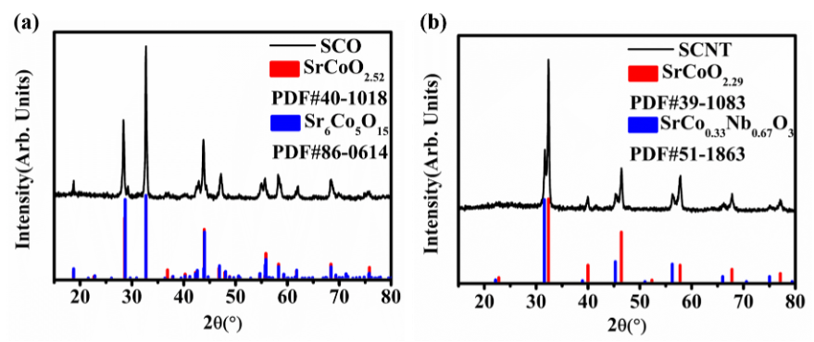

Fig.1

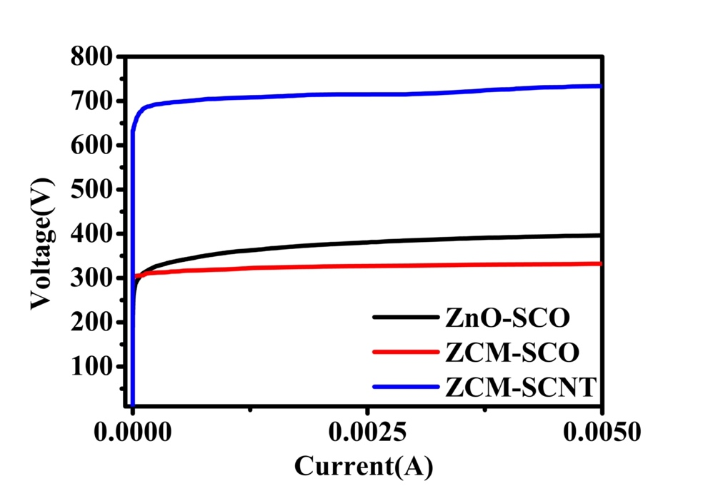

Fig.2

Fig.3

Fig.4

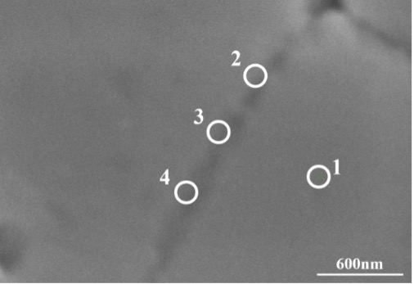

Fig. 5

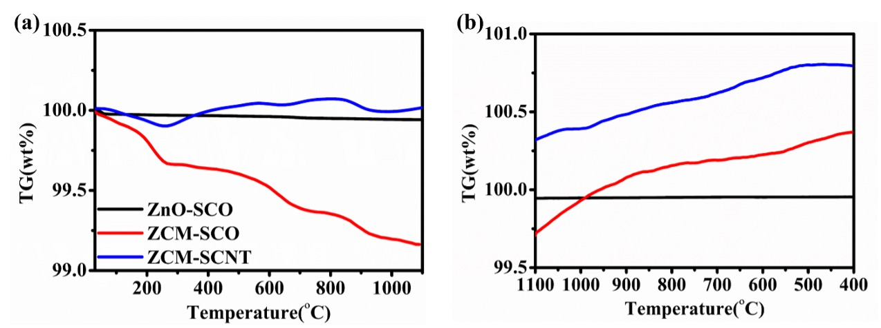

Fig.6

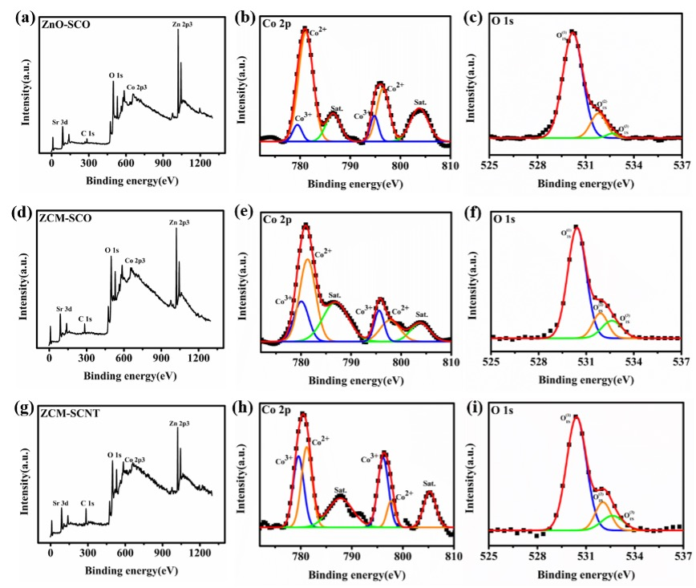

Fig.7

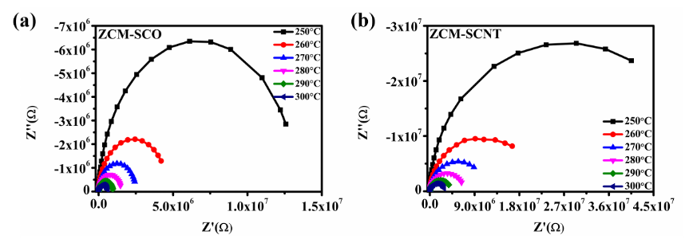

Fig.8

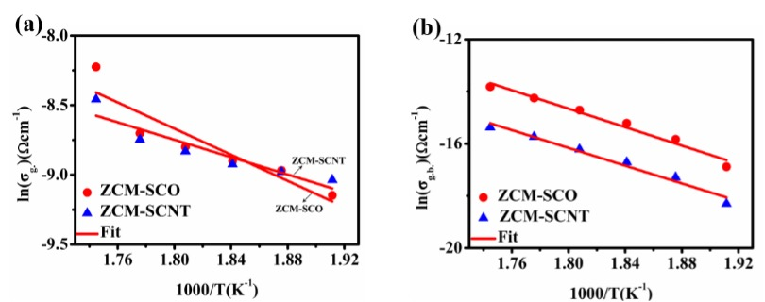

Fig.9

Fig.10